Association of Clinical Electron Microscopists ACEM Executive|
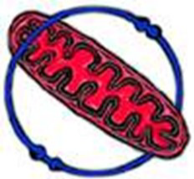

Agenda topics 7th September 2022:Teams
- RMS website
Alison
Send out actions
Email RMS
• request to update some content including overlay renal image,layout possibilities and members area ( I suggested the training/education tab has education, portfolio training, books and quality as drop downs as the NEQAS has education aspect?)
• DD vs SO availability
• Footer content to be our ACEM icon, Twitter link and email address

Patricia
• PCD text and image
• New renal image for website

Glen
• Paediatric text and images
• Bank information re membership DD

Bev
• Nerve text and image
• Update of muscle image if you would prefer another image to what's there

Bart
• Skin text and image
• Book list( we can always put a caveat in that not all the books are currently available )

A few items were not actioned to anyone specifically

• Can someone please send me the committee members full names and titles that would be great and I can pass this on
• the ACEM Twitter #

We did have a email address , I am looking into whether this is still active or not as was associated with the old site and an external mailbox so I am not sure but will investigate, if not I will ask Lucy best way to get this up and running

I will also look again at the website and see if there is anything else re typos etc

- Meetings
- ACEM 2023
- Education and Trining – IBMS update

- New ‘state of EM’ survey?

- Committee membership

- AOB

